Printing An Overdue List

1) Open the Report Tool
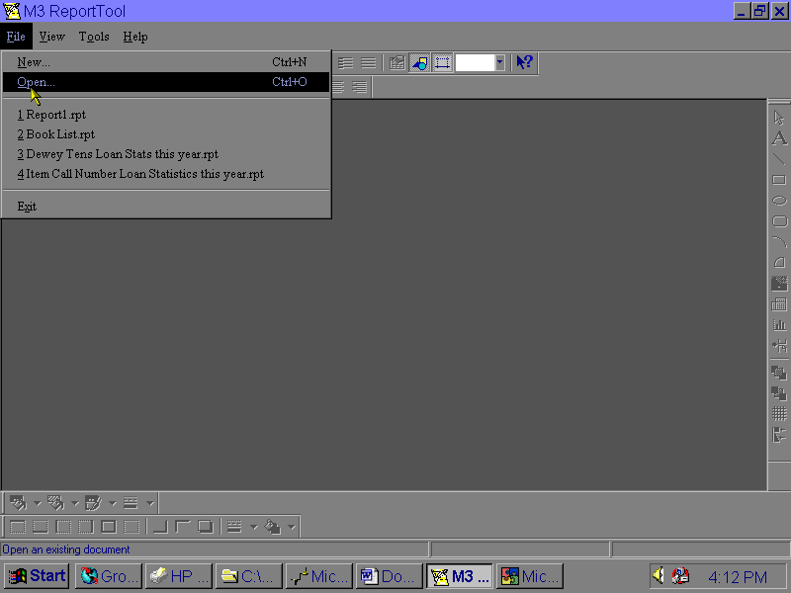
(Start…Programs…SIRS Mandarin M3…Report Tool)
2) Click the File Menu, then Open.

3) When the dialog box opens, you can choose the report you wish to use. If it does not appear in the list, use your mouse to scroll to the right until you see it .

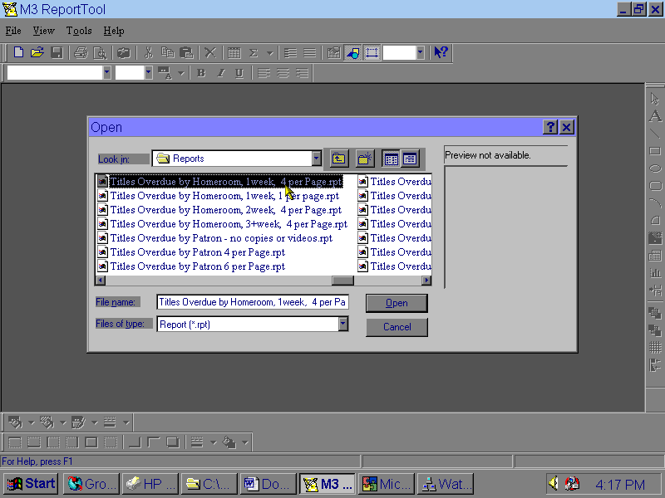

4) Find the report you wish to use and double-click it, or click on it once to highlight it then click Open.
(Note: If the reports do not show in the window or if you are getting things other than reports, be sure “Files of Type” is set to “Report - *.rpt”)

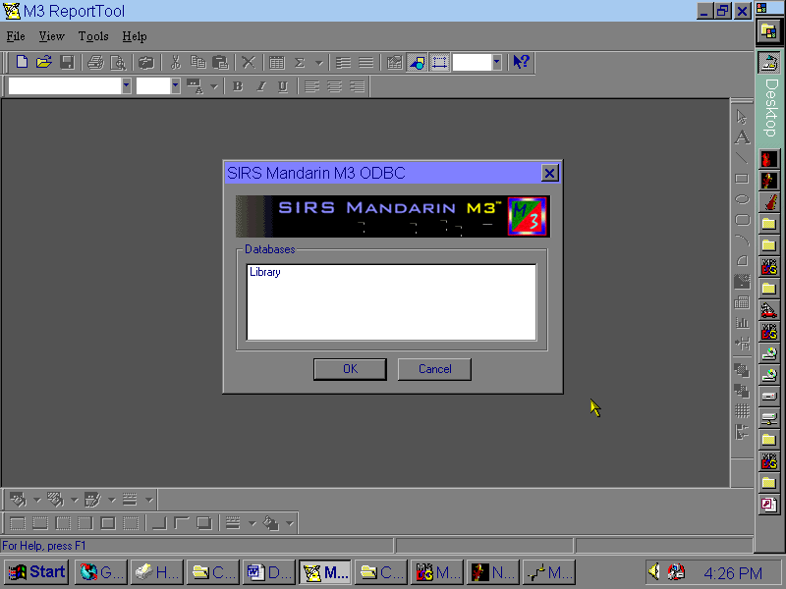
5) It will ask you to confirm which database you are using – double-click “Library” or click on it once to highlight it then click OK.
6) When the report opens, you usually will not need to make any changes. You can look at the report before it prints out by clicking the Print Preview button or by going to the File menu and choosing Print Preview. Whether you choose to look at the report or not before you print it, please check to be sure that the camera button is NOT pushed in.
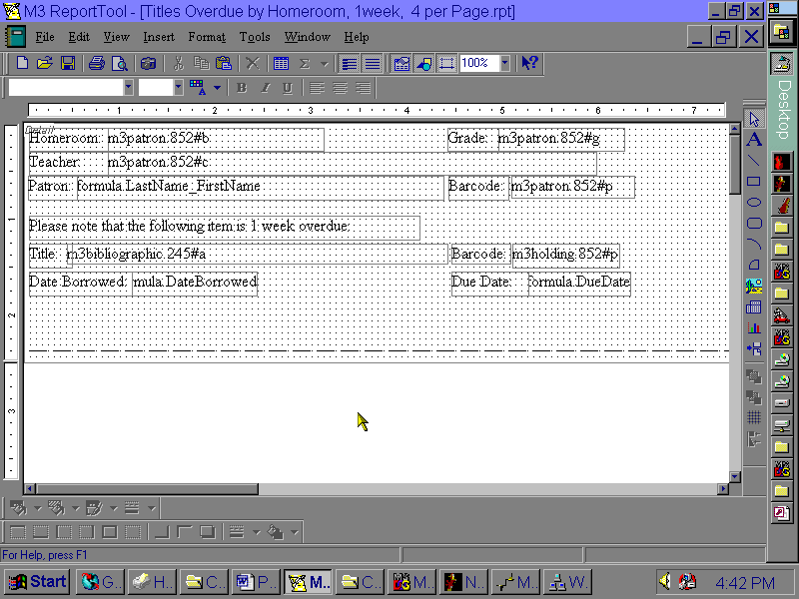

To print, click File, then Print or click the Printer Icon on the Toolbar. You may choose how many copies you want printed and whether you want the entire report or only part of it. When you have these settings adjusted, click OK.

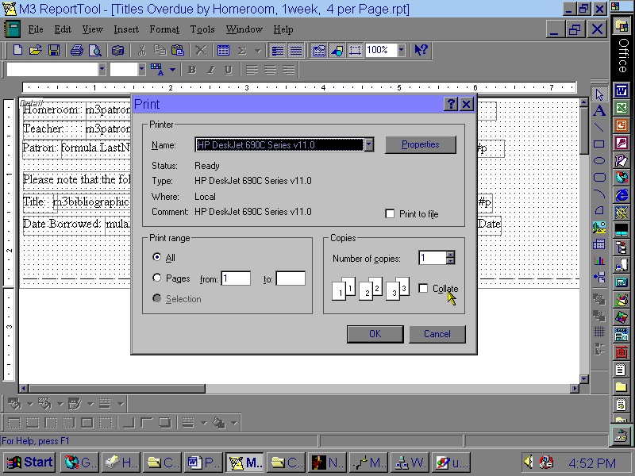
No. of copies
All or part of report

